**WEEK 01 PROGRAMS**



**AIM :** Installation of Simulation Tools (packet tracer and NS2)

**CISCO PACKET TRACER INSTALLATION**

**PROCEDURE :**

**Step 01 :**

Go to the official Cisco Netacad website. Once you’re logged in click on “RESOURCES > DOWNLOAD PACKET TRACER”.

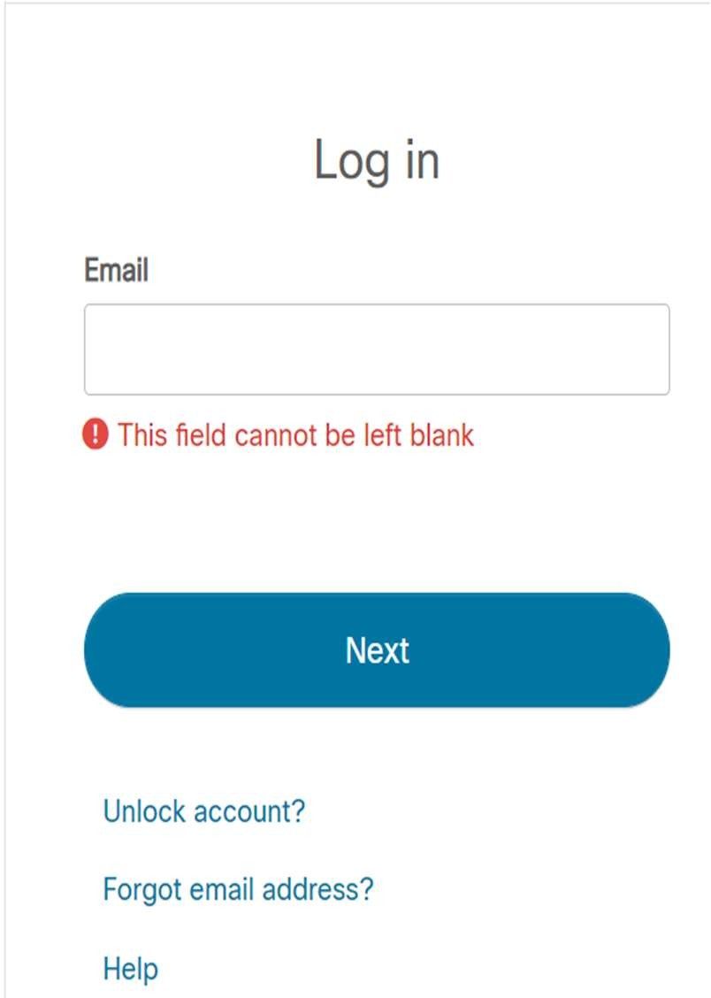 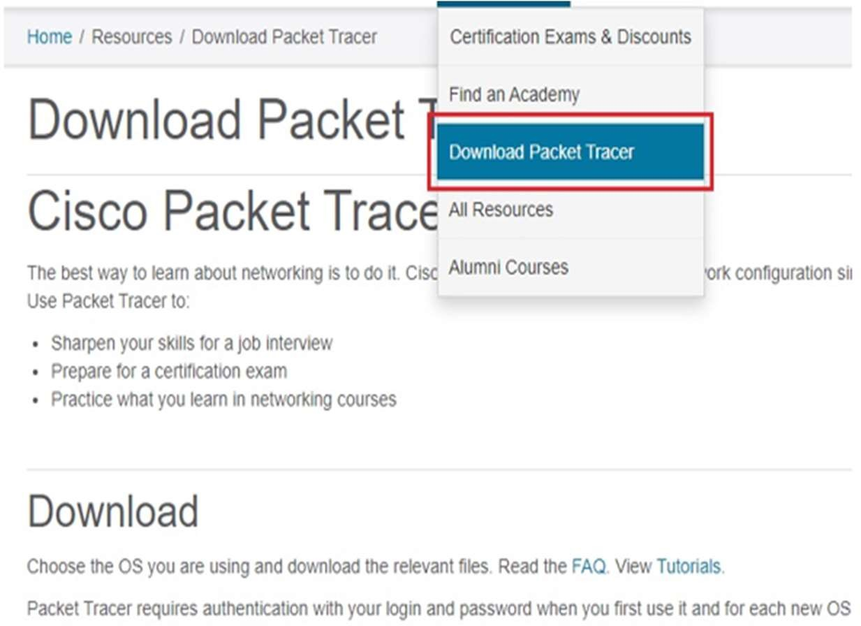

Now the file will be downloaded in the Downloads folder of the machine.

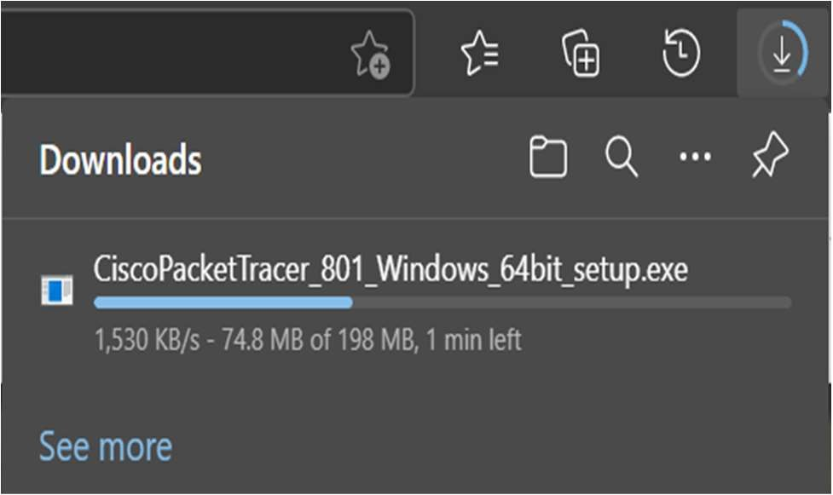

**Step 02 :**

Next, open the folder where the Packet Tracer setup file has been downloaded to and double click on the setup file.

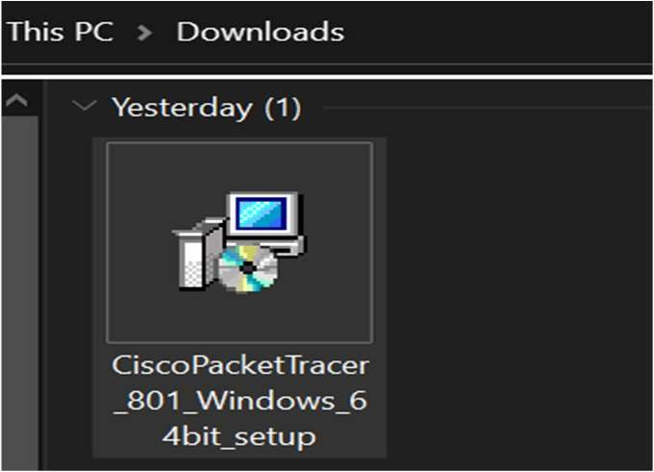

**Step 03 :**

On the packet tracer software license agreement select the “I ACCEPT THE AGREEMENT” radio button and click on “NEXT”.



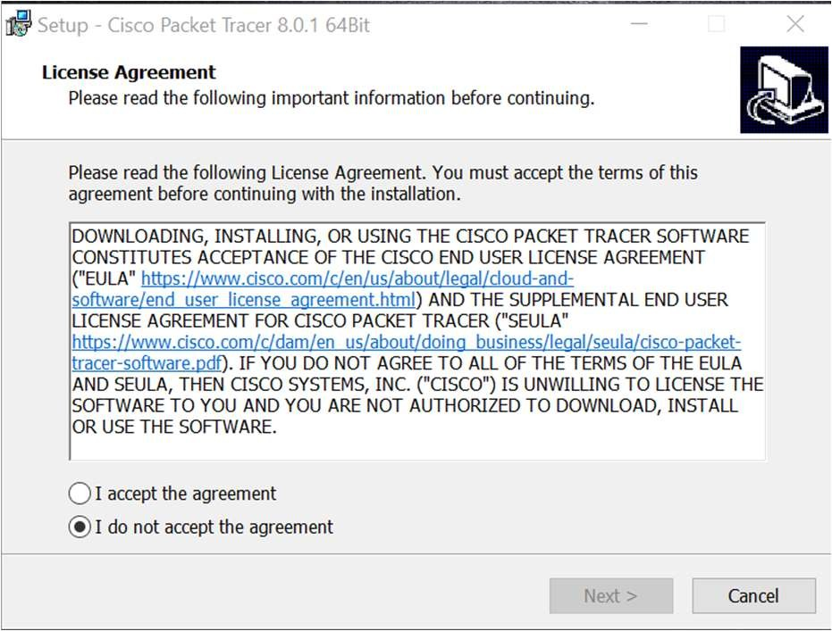

**Step 04 :**

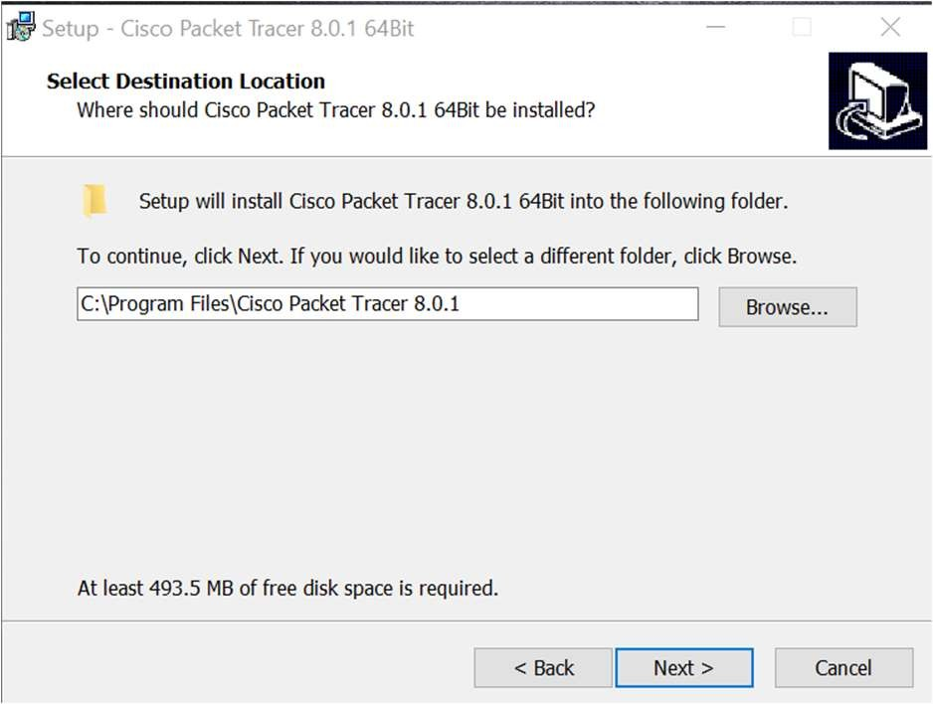To choose a destination folder where Cisco Packet Tracer will be installed click on the “BROWSE” button. However it is always recommended to use the default folder. Click on “NEXT” to proceed.

**Step 05 :**

* On the “SELECT START MENU” section choose a folder where Packet Tracer shortcuts will be created and click on “NEXT”
* On the “ADDITIONAL TASKS” section you can also choose to “CREATE A DESKTOP SHORTCUT” and to “CREATE A QUICK LAUNCH SHORTCUT”

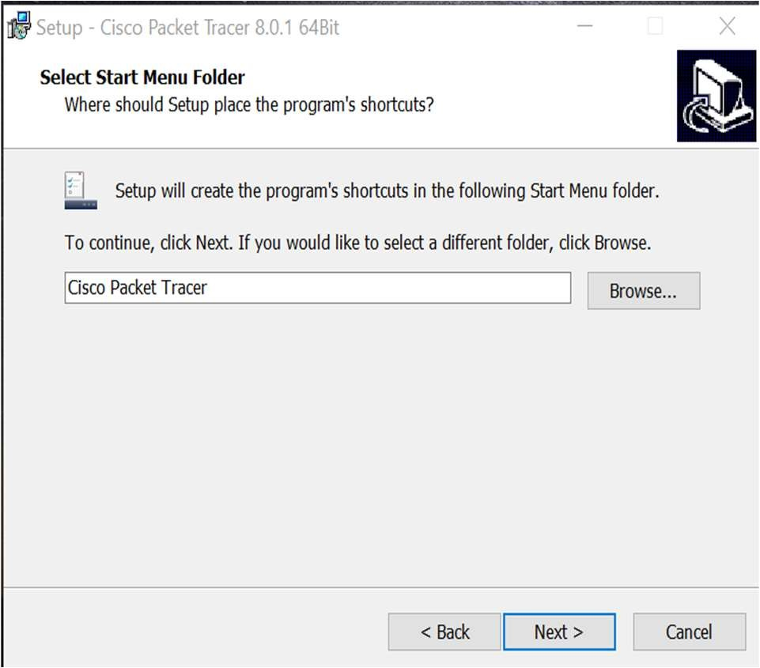 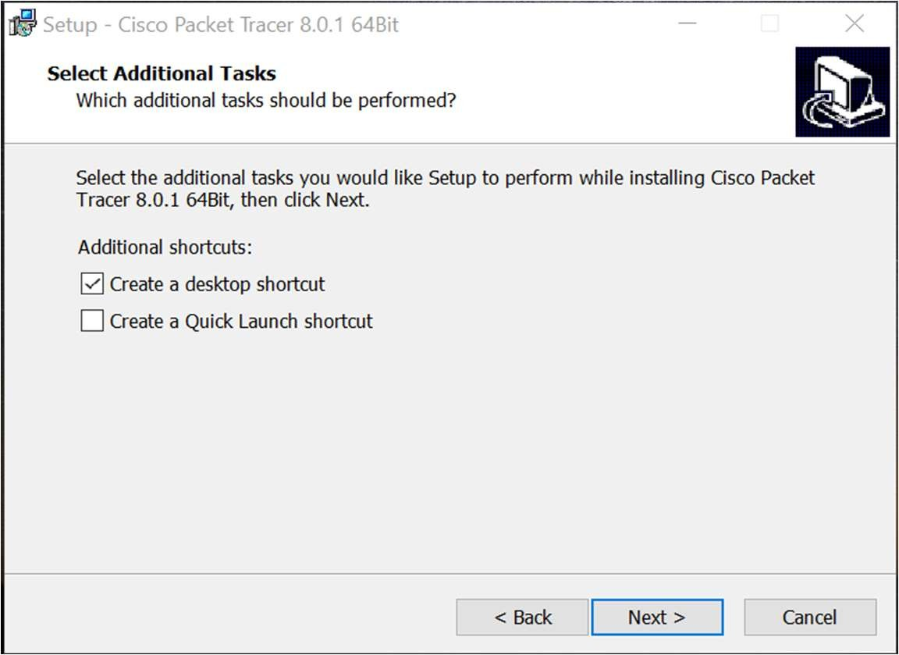

* + Click on “NEXT” to proceed, on the “READY TO INSTALL” section click on the “INSTALL” button.

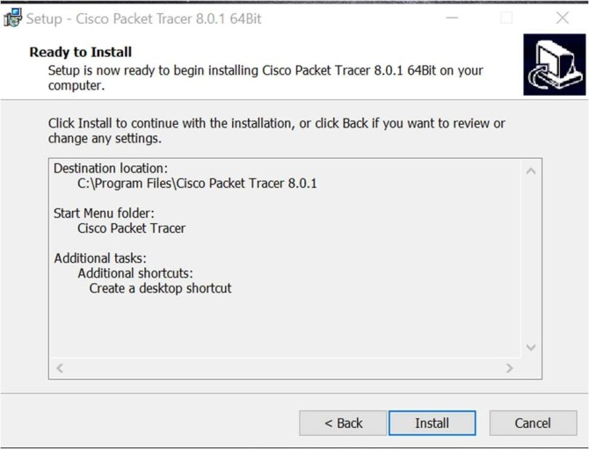

**Step - 06 :** Now the Installation will be done as follows,

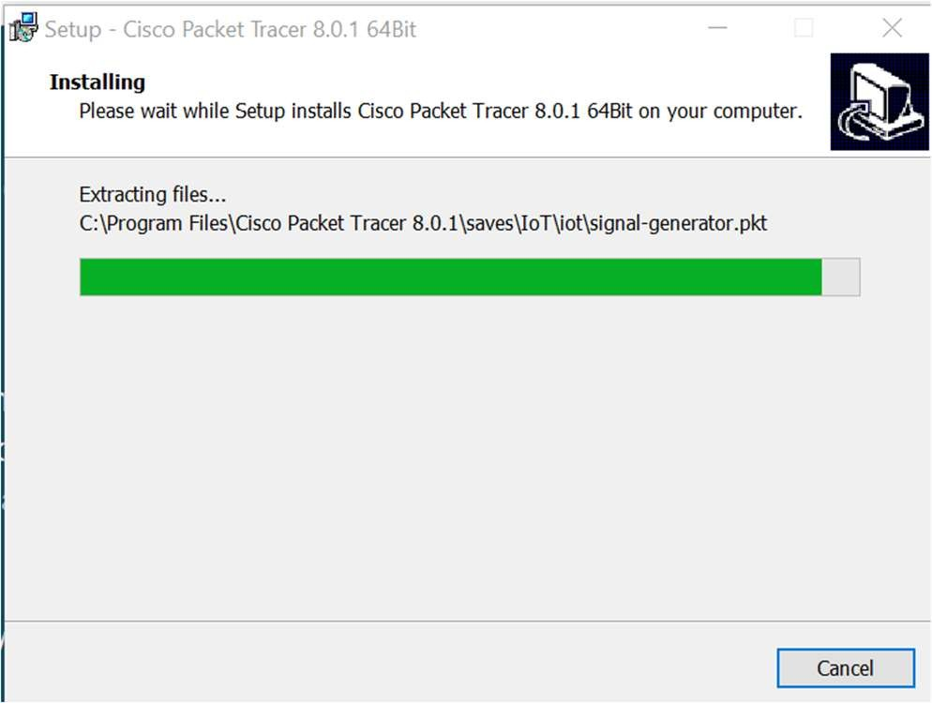

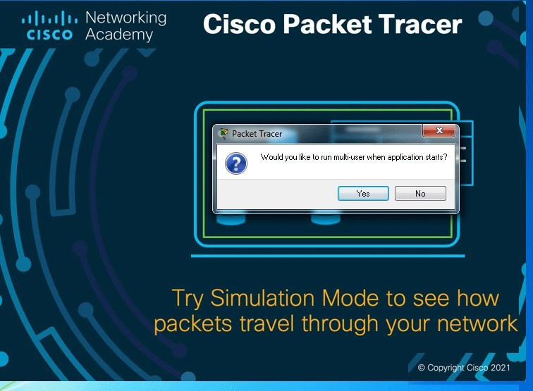**Step – 07 :** After the Installation Process is done, know double click on the Cisco Packet Tracer desktop icon and enter your NetAcad login credentials. The Packet Tracer user interface will be displayed and you can now start designing and simulating CISCO networks.

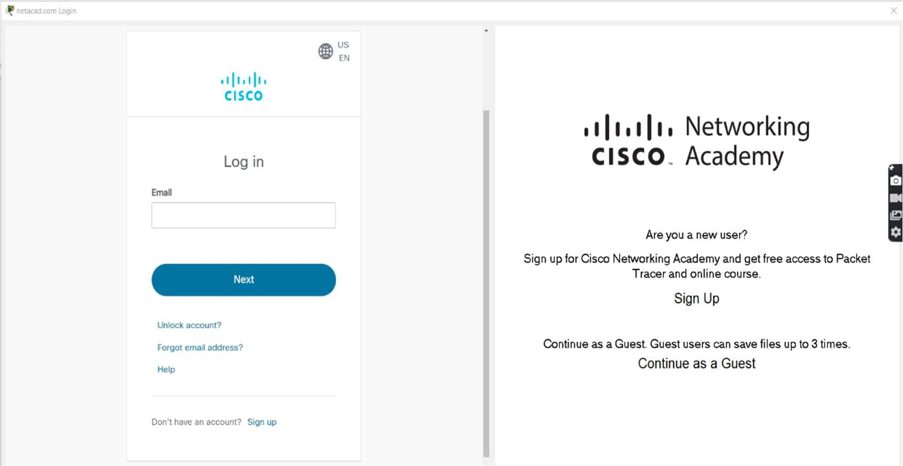

**Step – 08 :** After a successful login, the cisco packet interface appers as shown in the below image.

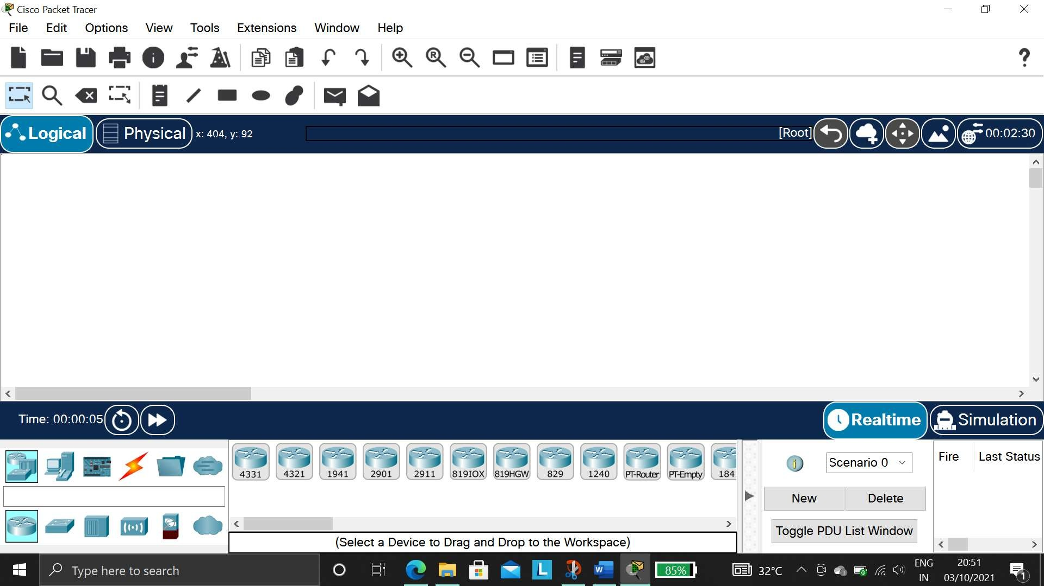

Step – 09 : Once it is done, the user can access all the contents of the cisco packet tracer.

* + - **NETWORK SIMULATOR (NS2) INSTALLATION**



**Step - 01 :** Please go to below given link and download the three .rar files after that place these files into in a single folder.

**Link :** How to install NS2 on windows 7 with the help of Cygwin Window | DP Project Development (wordpress.com)

* Part 1:NS 2.35-Part1

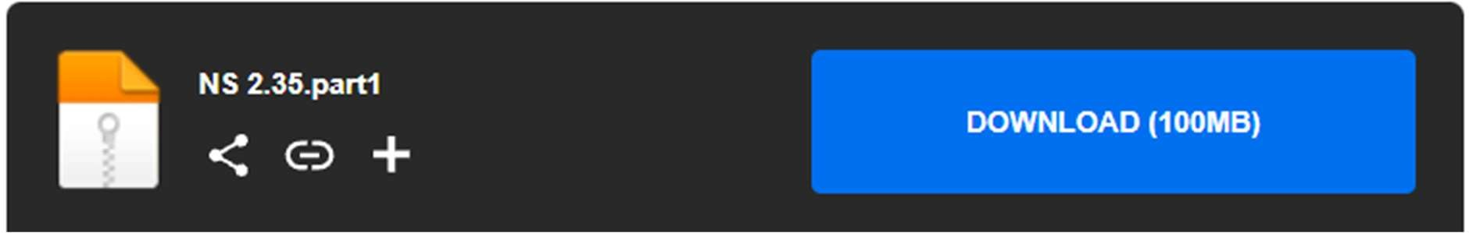

* Part 2:NS 2.35-Part2

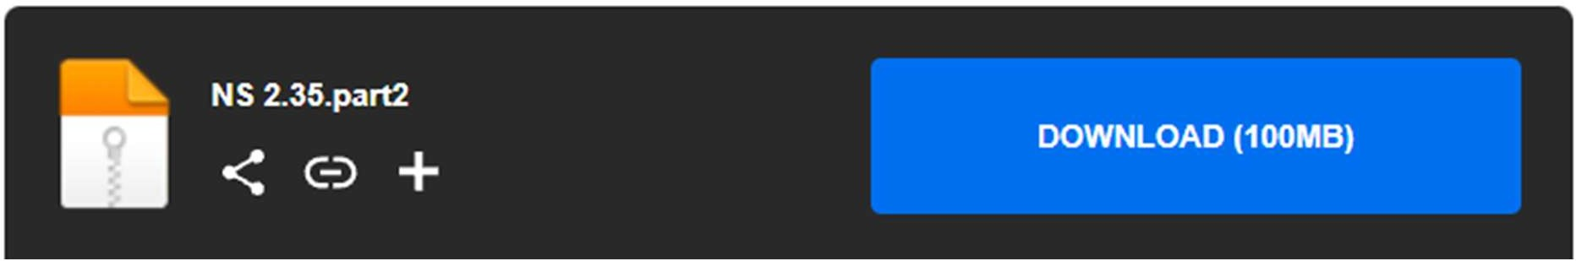

* Part 3:NS 2.35-Part3

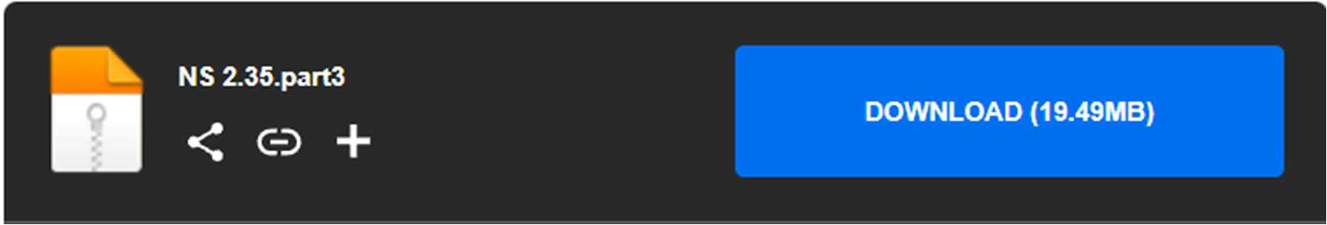

**Step 2:**

* + Now Extract the NS 2.35.part1 only. It will extract the part2 an part3 automatically.
  + Extract after the download is complete.
  + Part 2 and Part 3 will automatically be extracted.

**Step 3:**

* + 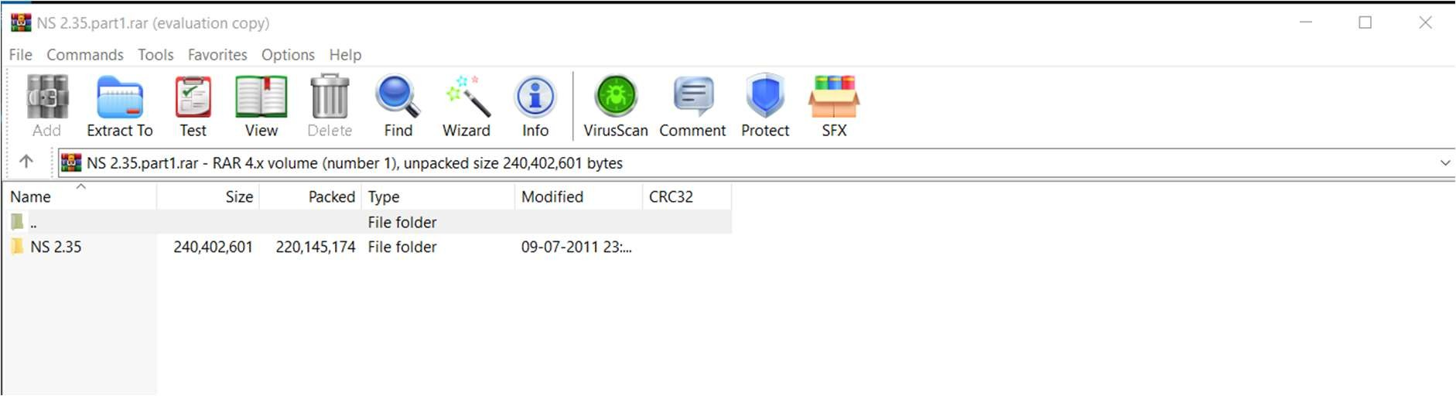After extraction you’ll get a folder named NS 2.35
  + Inside this folder you get cygwin setup, .bashrc etc..

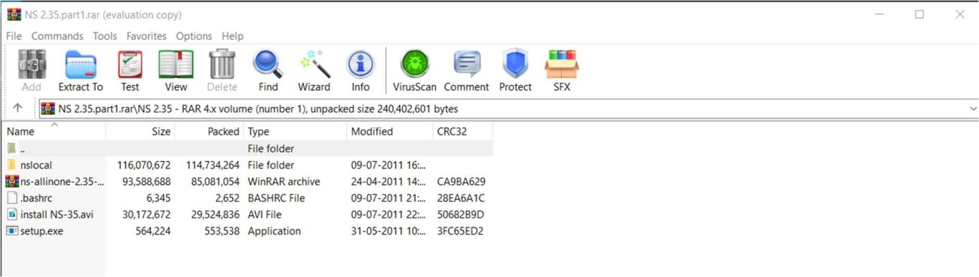

* + Now install the setup. Choose install from local directory
  + Press Next
  + Don’t change the default Root Directory
  + In Local Package Repository field browse to: NS 2.35/nslocal/release
  + Click Next
  + Click on the Circle
  + After clicking the circle, the default turns to install
  + After this press Next it will install the necessary packages for NS2
  + Check create a desktop shortcut and start menu shortcut
  + Then installation finished.
  + Now you are halfway done!

**Step 4:**

* + 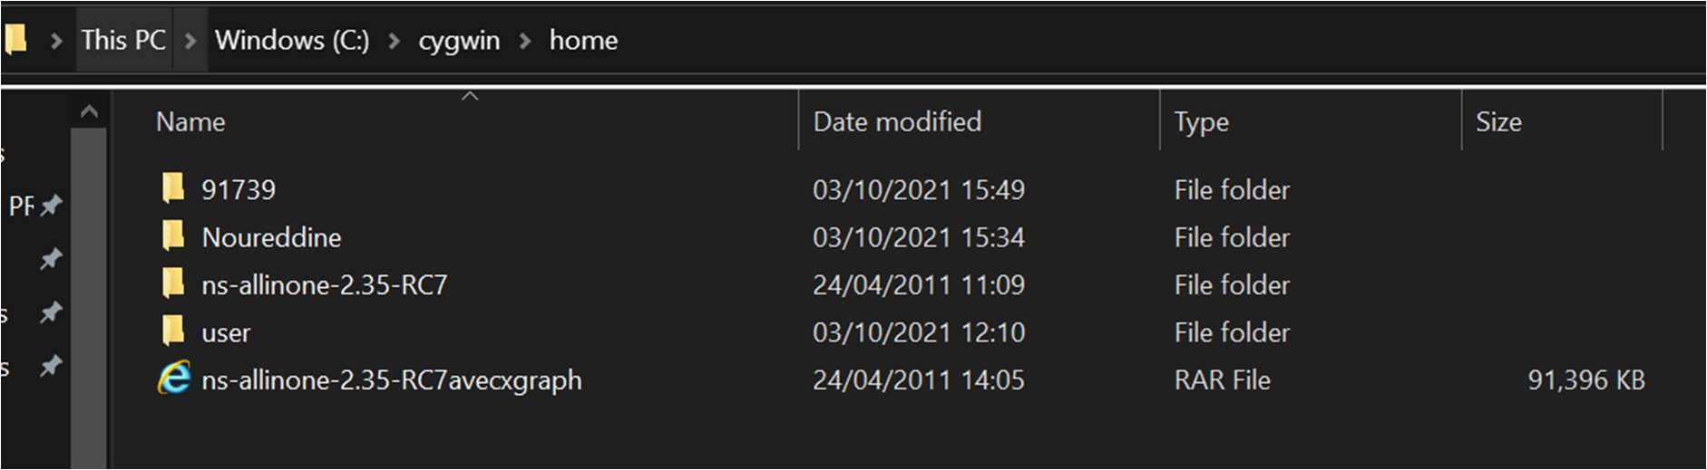Now create a folder Named Noureddine inside the C:\cygwin\home.
  + Now copy the ns-allinone-2.35-RC7avecxgraph.rar and Extract there. You’ll get ns- allinone-2.35-RC7 folder.

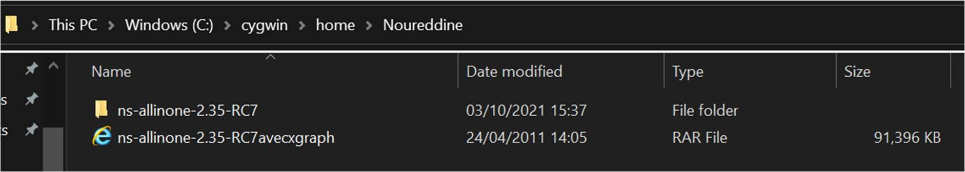

* + Now copy the .bashrc file from the downloaded Extract folder.
  + Now go to the “C:\cygwin\home\user” folder and replace (i.epaste) the .bashrc file that is copied.

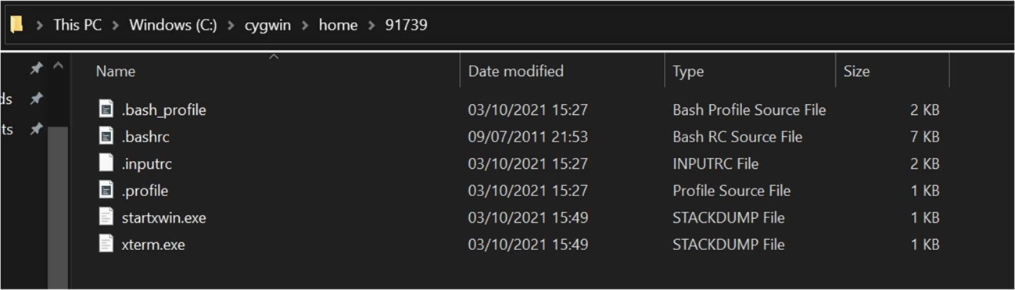

* Now open the Cygwin command window which is on your desktop and type source .bashrc
* 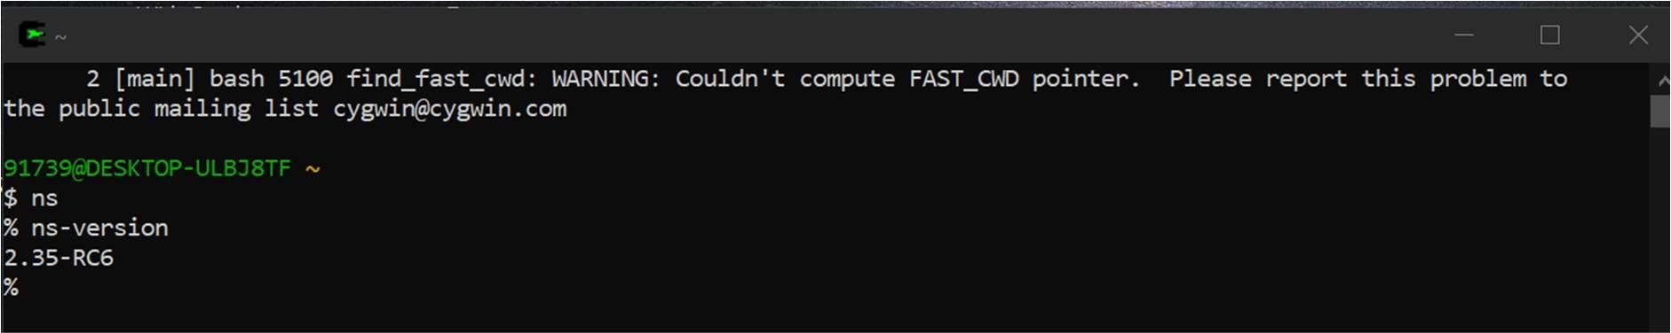Now type ns then the symbol “$” change to “%”
* Now press exit.
* Now type startxwin you’ll get a new window.
* Now type name you will get a screen.
* Now go to file and quit the name window.
* Now hold the main tab and drag your mouse to quit from Cygwin window (the white window)
* And exit from ‘cygwin command’ window (type exit).